MMS’s QUALITY POLICY
MMS aims to ensure that our products/services meet the needs of our customers at all times in accordance with customer, statutory and regulatory requirements, as well as our policies and procedures.
Senior management are responsible for the implementation of our Quality Management System and for achieving and maintaining ISO9001:2015 certification. The scope of our Quality Management System covers all activities stated within our Scope Document and we are committed to:
- Develop and improve our Quality Management System
- Continually improve the effectiveness of the Quality Management System
- The enhancement of:
- Quality, specification, and integrity
- Customer satisfaction
- Supplier performance
- Risk minimisation
- Work ethics and best practices
MMS has a continuing commitment to:
- Reviewing the internal and external issues affecting our Quality Management System and the needs and expectations of interested parties
- Ensuring that our customer needs and expectations are determined and fulfilled with the aim of achieving customer satisfaction
- Communicating throughout the Organisation the importance of meeting customer needs and all relevant statutory and regulatory requirements
- Establishing this Quality Policy and our ongoing Quality Objectives
- Ensuring that Management Reviews not only set but review the quality objectives, and report on the Internal Audit results as a means of monitoring and measuring the processes and the effectiveness of the Quality Management System
- Ensuring the availability of resources
We shall endeavour to comply with all relevant statutory and regulatory requirements, and constantly monitor our quality performance against objectives and implementing improvements when appropriate.
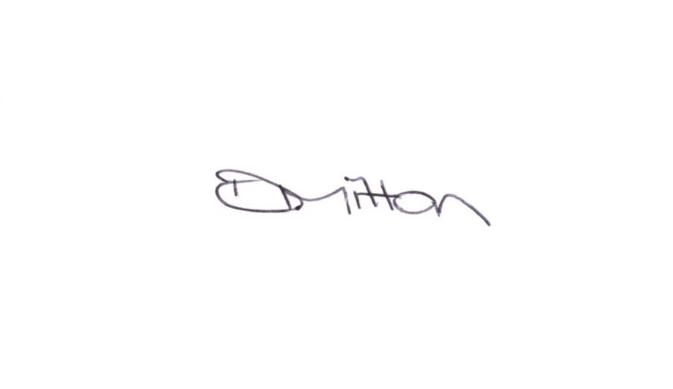
All personnel understand the requirements of this Quality Policy and abide with the requirements of the Quality Management System as defined in our Quality Procedures Manual. This Quality Policy is regularly reviewed in order to ensure its continuing suitability.
Copies are made available to all members of staff and relevant interested parties along with copies of the minutes of Management Reviews, or extracts thereof, in accordance with their role and responsibilities as a means of communicating the effectiveness of our Quality Management System.

Signed Name: Danielle Mitton Date: 05 March 2025

